

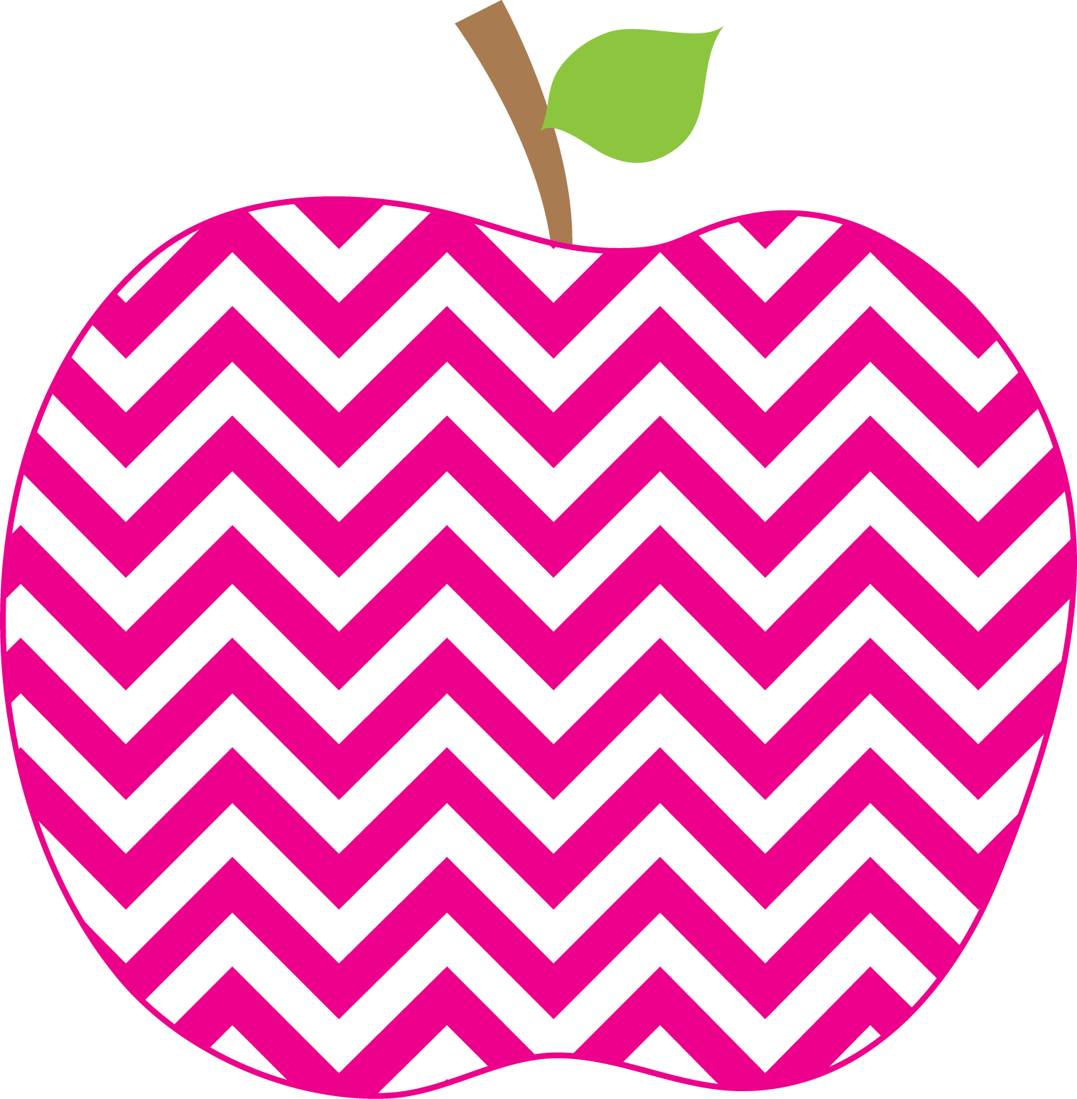



Austria’s Class News
Ms.
October 25, 2024

Phonics- This week we have been learning that when there are two letters together that are the same letter (ll, ss , and zz) they make only one sound.

Reading- We are continuing to learn about the five story elements when we are reading (character, setting, events in the beginning middle and end, problem and solution). We also began our small groups and are working on various skills in our groups.

Writing- We have continued to write about small moments and to add as much detail to our writing as possible. Additionally, we are continuing to add emotion and expressions to our writing so when others read our writing they know exactly how we feel throughout our writing. This week we have been learning to add transition words to our writing (Frist, Next, Then, and Finally).

Math- We are continuing to learn how to solve word problems. This week we have started to learn about bar graphs and pictographs. We are learning how to make tally marks when counting objects to graph.

Science- We have begun Science this week! This week we have been learning what Matter is and the different properties that Matter has. We have also been learning how to sort objects according to their properties. We conducted experiments this week to test the flexibility of objects and also the absorbency. The experiments were enjoyed by the class!

**The class has been enjoying having Music Therapy every Tuesday! It has been a lot of fun singing songs together!

This Week’s Focus
Celebrations
Fall Party October 30th

Elijah’s Birthday November 2nd!

Please remember to return permission slips for the Nutcracker if you have not done so yet. Thank you!

Please send in snacks and treats on Wednesday (10/30). Have your child wear a Halloween shirt. Costumes are ONLY worn on Halloween. Thank You
Parent Teacher conferences are scheduled for November 20th, 21st and 22nd.
Reminders
Upcoming Events

